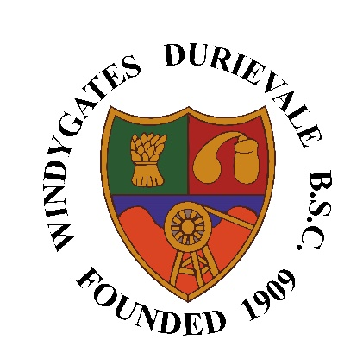**Windygates Durievale**

**Bowling & Sports Club**

**Membership Application Form 2024**

|  |  |
| --- | --- |
| **Name** |  |
| **Address** |  |
| **Postcode** |  |
| **Phone number** |  |
| **Email address** |  |
| **Previous bowling club membership (if applicable)** | |
|  | |
| **Date of leaving or if current member** |  |
| **Membership application**  (delete as appropriate) | Full Junior Senior Social |
| **Date of application** |  |

|  |  |  |
| --- | --- | --- |
| **Name of referring bowling member (if applicable)** |  | |
| **Top (£26)** | Size | Quantity |
|  |  |
| **Waterproof jacket (£56)** | Size | Quantity |
|  |  |

Membership acceptance is conditional of approval by the Club Committee after application form has been displayed on the club noticeboard for a period of two weeks from application.

|  |  |  |  |
| --- | --- | --- | --- |
| **Committee approval 1** | | | |
| Signed |  | Date |  |
| **Committee approval 2** | | | |
| Signed |  | Date |  |

**Once completed, hand application forms directly in to the club, email to** [**windygatesbc@gmail.com**](mailto:windygatesbc@gmail.com) **or send by post to: Windygates Durievale Bowling & Sports Club, Leven Road, Windygates, KY8 5DA**